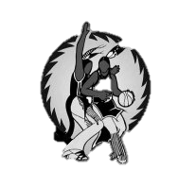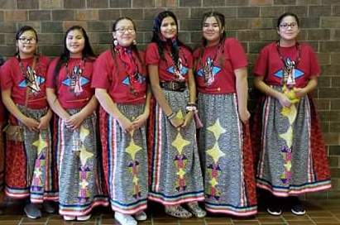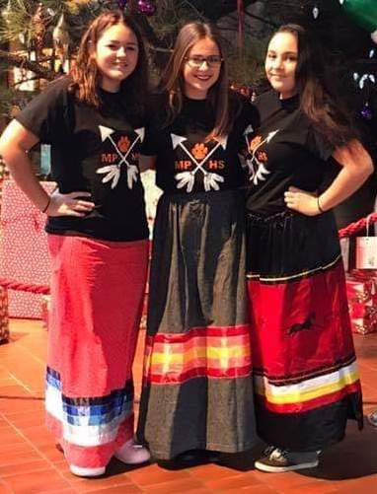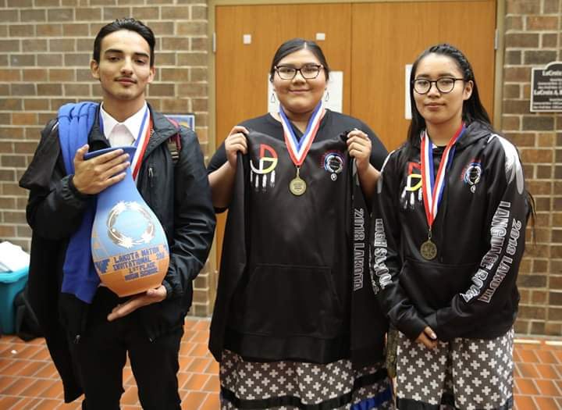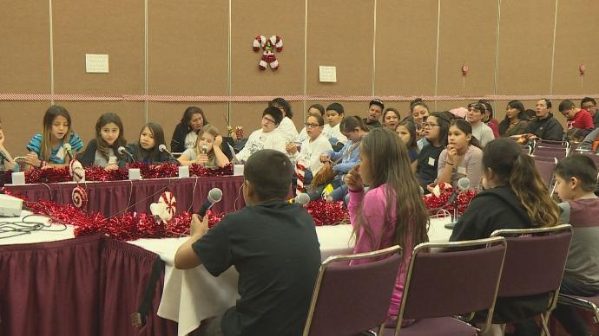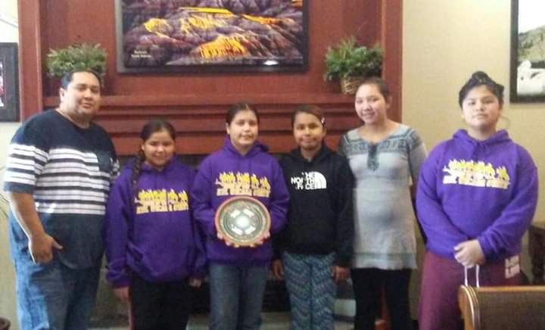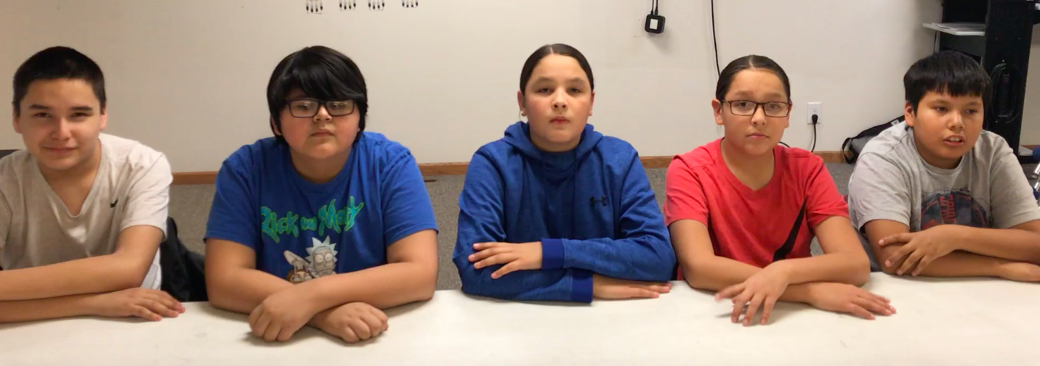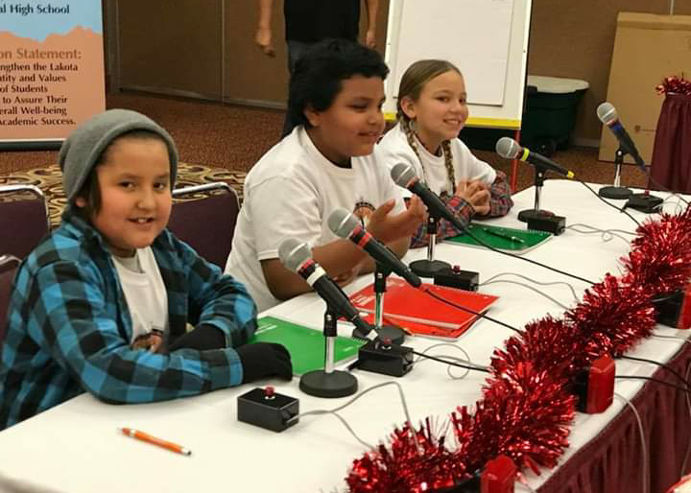

Team fee is $250.00 per team. Teams must be paid by Friday December 3rd , 2021.

Please submit payment to:

**Lakota Nation Invitational**

**3213 W Main St #425**

**Rapid City, SD 57702**

Registration deadline is Friday, December 3rd, 2021. Only teams that are registered by the Deadline will be recognized on the official list. You may register your team online, email or mail your registration to:

[**https://www.lakotanationinvitational.com/lakota-language**](https://www.lakotanationinvitational.com/lakota-language)

**Email: Jennifer.SpottedBear@k12.sd.us**

**LNI Lakota Language Bowl**

**C/O Jennifer Spotted Bear**

**Oglala Lakota County School**

**206 School Street**

**Batesland, SD 57716**

**​Phone: (605)288-1921**

**(605)-454-3991**

​

# *21sth Annual LNI Lakota Language Bowle Bowl*

:a

LNI

# *December 15 t h , 16th & 17 th 2021 Rushmore Plaza Civic Center CenteCivic Center*

Welcome to the 21st Annual LNI Lakota Language Bowl!

In celebrating our twenty first year, we are excited to invite your school to participate in our Language Competition. In the last twenty years, the LNI Lakota Language Bowl has given both Lakota and Dakota students an opportunity to showcase their linguistic knowledge, in the spirit of competition. There will be changes in celebrating our 21st Anniversary. This year, the High School Division will compete the first day, December 15th, 2021. The Middle School Division (K-5) will compete the second day of the language bowl on December 16th, 2021. The Elementary Division will play on December 17th, 2021. In closing, we want to take this opportunity and thank all the organizers over the last twenty years, for their dedication in building the LNI Lakota Language Bowl. We want to thank all the schools, coaches, volunteers, and students who have participated. Finally, we want to thank the Lakota Nation Invitational for their continued support in advocating and encouraging Lakota Language and culture in our schools and throughout the Očhéthi šakówiŋ. We want to wish all the teams safe travels; the best of luck and we look forward to seeing you in December in our beautiful Black Hills.

# *December 18 t h & 19 th 2019 Rushmore Plaza Civic Center CenteCivic Center*

***Lakota Nation Invitational Lakota Language Bowl 2021***

***Team Registration Form***

***School Representing: ______________________________________________________________________***

***Name of Team: ____________________________________________________________________________***

***Adult Team Sponsor(s): ____________________________________________________________________***

***Sponsor Contact Phone/Email: _____________________________________________________________***

***Circle one of the following 4 competition levels for your team***

***Team Roster***

***Elem. team (K-2)(3-5), Middle School (6-8), High School Team (9-12)***

***Name:***

1. ***______________________________________________________________________________________***
2. ***______________________________________________________________________________________***
3. ***______________________________________________________________________________________***
4. ***______________________________________________________________________________________***
5. ***______________________________________________________________________________________***
6. ***(alternate) ___________________________________________________________________________***

***If taking two or more teams from one school, please fill out a registration form for each team.***

***You may register online:*** [***https://www.lakotanationinvitational.com/lakota-language***](https://www.lakotanationinvitational.com/lakota-language)

***You can also mail registration forms to:***

**REGISTRATION & MEDIA FORMS ONLY (NO CHECKS PLEASE)**

***LNI Lakota Language Bowl***

***Oglala County School District***

***C/O Jennifer Spotted Bear***

***206 School Street***

***Batesland, South Dakota 57716***

***REGISTRATION IS DUE NO LATER THAN FRIDAY, December 3rd, 2021***

**Lakota Nation Invitational Lakota Language Bowl 2021**

**Team Registration Form**

**Lakota Nation Invitational Lakota Language Bowl competition Structure**

**Traditional/Contemporary Song Competition (Grades K-12):**Must be done by the entire team itself. Team will perform song in Lakota at the Language Bowl. Any traditional or contemporary song can be selected. The song can also be an original composition. The use of a hand drum will be allowed. ***Examples but not limited to****: The Lakota Flag Song, Itsy Bitsy Spider (Lakota version) Round dance, Pow-wow, Honoring Songs, Love Songs, The Lakota Counting Song, The Lakota Days of the Week song.*

**Traditional Demonstration Competition (Grades K-12)**: Elementary and Middle School teams can have up to three minutes to complete their live demonstration, but no less than a minute. High school teams can have up to 5 minutes to complete their demonstration, but no less than 3 minutes. Time allotted starts when the students get to the table. No exceptions and the time keepers will not wait. Traditional demonstrations must be done live and spoken in Lakota Language. No English words will be allowed. No Scripts will be allowed. No team coaches/sponsor are allowed in any part of the demonstration. Students have the creative option to choose a demonstration of their choice. **Examples but not limited to:**Beading/Beadwork, Quill work, setting up small scale tipi, Making/Drying Papa, Fixing/Combing Hair, Making a sandwich.

**Picture Competition (K-2):** This is a bracket competition with a moderator. Teams competing against each other will be shown a picture by the moderator individually for student to name picture in Lakota. Students will have 10 seconds to state the word after shown picture. If student is unable to answer correctly, the word will be extended to the opposite team. If the other team is unable to answer correctly no point is award to either team. Each word answered correctly will be given one point. The first team who receives 10 points wins the round.

**Lakota Speed Vocabulary Competition (Grades 3-12):**This is a bracket competition with a moderator. Teams competing against each other will be given a vocabulary word by the moderator. Students from either team can then ring the buzzer, if they know the answer. Students will have 10 seconds to state the vocabulary word, once they ring the bell. If a student is unable to answer, neither team gets the point. Each word answered correctly, will be given one point. The first team answering ten vocabulary words, wins the round. If a student rings the bell, they must answer the question. If the student is unable to answer the question, neither teams gets the points and the Moderator will pick a new vocabulary word. Once a student rings the buzzer, there is no sideline discussion with their team. Students must keep their hands on the table at all times. No hand hovering over the buzzer will be allowed. There will be a Dakota speaking moderator available, along with our Lakota speaking moderator to negate any language difference. All LNI moderator decisions are official and final.

**Thematic Unit Speaking Evaluation Describing pictures. (Grades 3-12)** Older grades will be given a traditional picture to describe. Younger grades will be given a fun picture to describe. Correct use of words, sentences, and conjugation, will receive one point and the buzzer will start again. First team that gets to **10** first, will win that round and progress forward in the bracket. Once a team member hits the buzzer they are expected to answer the question. If a student fails to describe anything on the picture there will be no points given. Hands must be placed on the table. No hand hovering over the buzzer is allowed. There will be a Dakota speaking moderator available, along with our Lakota speaking moderator to negate any language difference. All LNI moderator decisions are official and final.

**Tradition through Media Technology** -NOT A COMPETITION. We are asking that all teams submit a zoom style recording. Introducing themselves, where they live, how old they are, and what school they attend. K-2 can send in a 1 page slide with group picture and student names, team name, school, and grade. Team submissions will receive 25 points. One video per team. Deadline is December 3, 2021



**21st Annual Lakota Nation Invitational Language Bowl**

Official Rules of Team and Coach Conduct

1. Teams must have at least three members to compete, and may have a maximum of five registered members, with one alternate allowed. A student may not be on two teams. Also, alternates need to be aware that if their team wins first place, they may not get a jacket.
2. All Lakota Language Teams must consist of enrolled students K-12. Team participation must be approved by the student’s respective school they are enrolled in.
3. Only teams who complete registration, media release form and pay the competition fee before the December 3rd deadline will be able to compete. Please check with your school’s business office (double & triple-check, if necessary) to ensure that they understand the need to meet this payment deadline! We don’t want to have any teams come all the way to Rapid City to compete, only to find that they were never put onto the bracket due to incomplete registration.
4. Teams must be checked in not later than 1 hour before the official competition start time. Registrations starts at 8:00 am. The competition will start with the High School on Wednesday, December 15th, starting at 10:00 am. The Middle School will compete on Thursday, December 16th at 10:00 am. Elementary School will start with the K-2 grades at 10:00 am and the 3-5 grades will follow at 1:00 pm.
5. Teams are highly encouraged to wear clothing that is reflective of the school they are representing.
6. Teams who will be late to the start of the competition due to the bad weather or other logistical issues need to contact Trina Lone Hill (605-944-1407).
7. Good sportsmanship must be displayed by all contestants, coaches, and spectators.
8. Teams should be gracious during competition, whether participating or watching, and at the end of every two-team round, the team members must shake hands with each other.
9. Negative behavior by any individual student, coach, or parent, during the competition will disqualify them from competing from that moment on. No poor sportsmanship, either from students or adults.
10. If a team disagrees with a call, the coach may bring the issue up with Kellee Brewer or Levi Left Hand in a constructive and non-confrontational way. ALL OFFICIAL MODERATOR and JUDGE’S DECISIONS ARE FINAL.
11. Harassment of any kind towards the LNI Coordinators, extended staff or to student participants is not permitted. Failure to comply will be removed from the event. In the event of harassment, please contact Kellee Brewer or Levi Left Hand immediately.
12. Alternate Rule: If an alternate is needed, the student must be checked in and registered on the morning of the respected competition. No substitution is allowed once the competition starts. Failure to comply, will result in disqualification from that respected competition.
13. Students are not allowed to hand hover over the buzzer during Speed Vocabulary or Thematic Unit competitions
14. Students should be prepared for their respective competitions prior to LNI. The use of scripts during the Traditional Demonstration or Music & Song competitions is highly discouraged. No coaches or sponsors are allowed to accompany, stand, or participate with their students while they’re competing.

**I understand and will comply with all LNI Lakota Language Bowl Rules and Regulations. This must be signed by the Team Coach or Sponsor for team to participate. Form must be given to Language Bowl Registrar at the event during team check-in.**

_______________________________________________ ___________________________

Coach Name Date

***Media Release Form***

***The LNI Lakota Language Bowl has my permission to use my child/child’s video for the purpose of the Lakota Language Bowl and any other areas promoting the Lakota Nation Invitational. This is for the Tradition Through Technology Media Competition at the LNI Lakota Language Bowl. If the student is 18 years old or older, they may sign their own permission slip.***

***Parent/Guardian’s Signature: _______________________________________Date_______________ Parent/Guardian’s Name: ____________________________________________***

***Child’s Name: ______________________________________________________***

***Phone Number: _____________________________________________________***

***All media release forms must be signed and submitted by coach/sponsor at registration.***

***.***

Wednesday December 15th, 2021

8:00 am Team Registration Opens

10:00 am Opening Ceremony

High School Competition:

* Traditional and Contemporary Song competition
* Traditional demonstration competition
* Lakota Speed vocabulary Competition
* Thematic Unit Speaking Evaluation (Picture Description)

Team Awards will be handed out following the Competition on Wednesday night.

Thursday December 16th, 2021

8:00 am Team Registration Opens

10:00 Opening Ceremony

Middle School Competition

* Traditional/Contemporary Song Competition
* Traditional Demonstration competition
* Lakota Speed Vocabulary Competition
* Thematic Unit Speaking Evaluation (Picture Description)

Team Awards will be handed out following the Competition on Thursday night.

Friday, December 17th, 2021

8:00 am Opening Ceremony

Elementary Competition:

K-2

* Traditional/Contemporary Song and Competition
* Picture Vocabulary
* Traditional Demonstration Competition

3-5

* Traditional/Contemporary Song and Competition
* Traditional Demonstration Competition
* Thematic Unit Speaking Evaluation (Picture Description)

Team Awards will be handed out following the Competition on Friday night.